EXPERIMENT:8: Create a simple cloud web application for student counselling system using any Cloud Service Provider to demonstrate SaaS with the fields of student name, age, address, phone, subjects studied, Year of passing, percentage of marks, domain interest, etc.

STEP:1 : CREATE A APPLICATION FORM STUDENT DETAILS.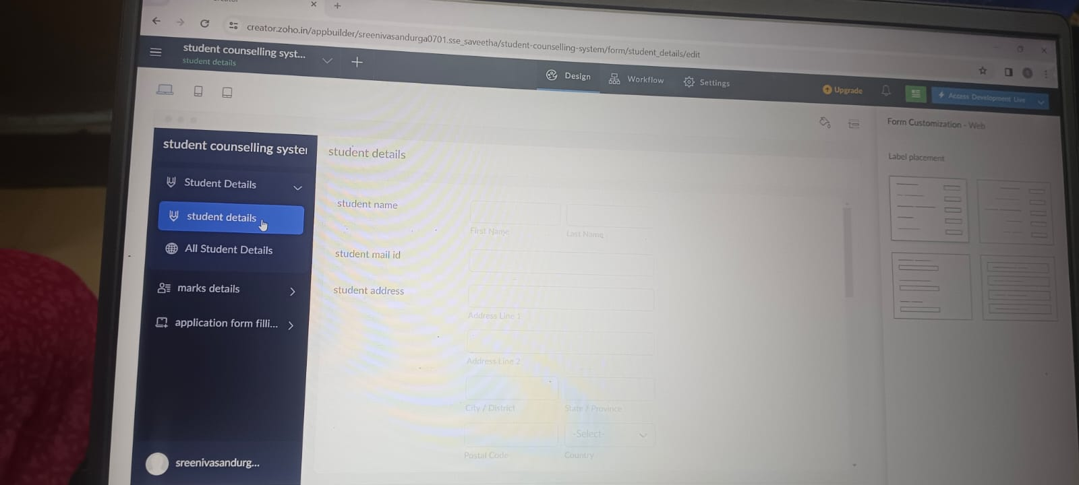

STEP:2: CREATE A APPLICATION FORM FOR THE APPLICATION FORM DETAILS.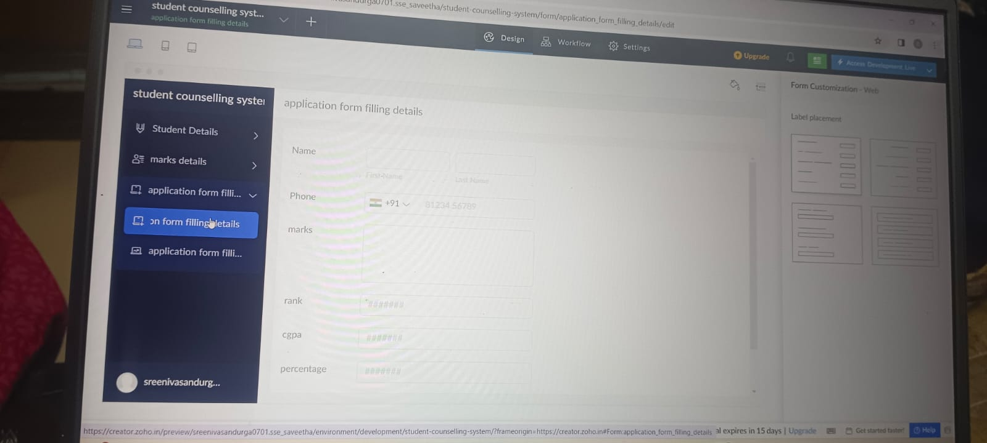

STEP:3: CREATE A APPLICATION FORM FOR THE STUDENT MARK DETAILS.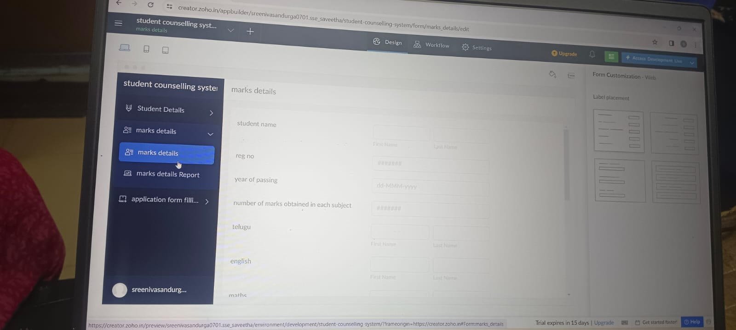

STEP:4: CREATE A APPLICATION FORM FOR THE STUDENT COUNSELLING RESULT.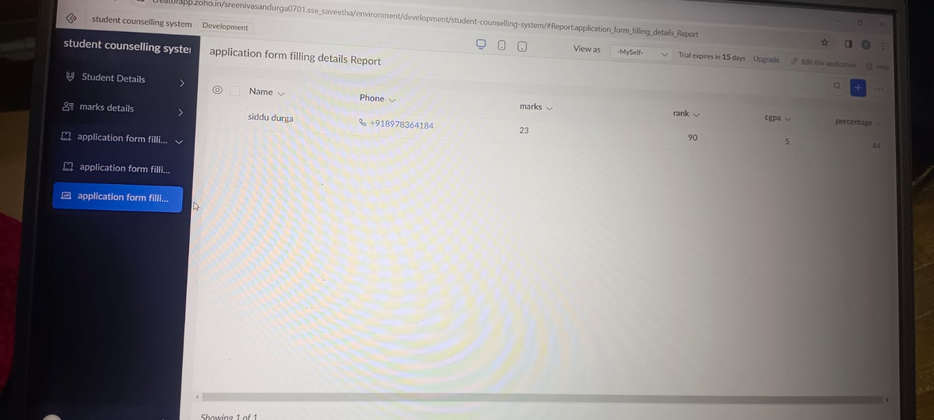

RESULT: THUS,THE PROGRAM FOR THE STUDENT COUNSELLING SYSTEM HAS BEEN EXCEUTED SUCCESSFULLY.